192524081 – DANIEL SAM K.

- ANALYSIS DEVELOPMENT AND VERICATION OF 8 BIT & 16 BIT ARITHMETIC OPERATIONS USING ASSEMBLY LANGUAGE PROGRAM

OBJECTIVES
- To develop and verify assembly language programs for performing 8-bit addition and subtraction using the 8085 microprocessor and observe the results stored in memory.
- To develop and verify assembly language programs for performing 16-bit addition and subtraction using the 8085 microprocessor and analyze the results obtained.
- To develop and verify assembly language programs for performing 8-bit multiplication and division using the 8085 microprocessor and check the accuracy of the results.
- To develop and verify assembly language programs for performing 16-bit multiplication and division using the 8085 microprocessor and validate the results obtained through memory locations.

COMPONENTS REQUIRED
- 8085 Simulator OR 8085 Microprocessor

PROCEDURE
- Open the 8085 microprocessor simulator software.
- Write and enter the assembly language programs for 8-bit and 16-bit
addition, subtraction, multiplication, and division.
- Store the input values in the specified memory locations.
- Execute the programs and observe the arithmetic operations performed by the microprocessor.
- Check the results stored in the specified memory locations.
- Verify the results by comparing them with the expected mathematical outputs.

- verify assembly language programs for performing 8-bit addition and subtraction using the 8085 microprocessor and observe the results stored in memory.

8 BIT ADDITION :
MVI C 00h
LDA 4200h
MOV B A
LDA 4201h
ADD B
JNC SKIP
INR C
SKIP: STA 4202h
MOV A C
STA 4203h
HLT

OUTPUT

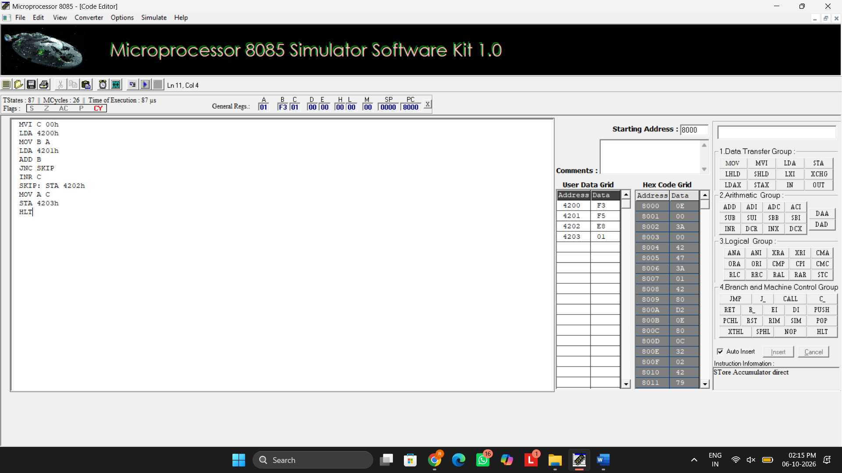
8 BIT SUBRACTION :
MVI C 00h
LDA 4201h
MOV B A
LDA 4200h
SUB B
JNC SKIP
CMA
INR A
INR C
SKIP: STA 4202h
MOV A C
STA 4203h
HLT

OUTPUT
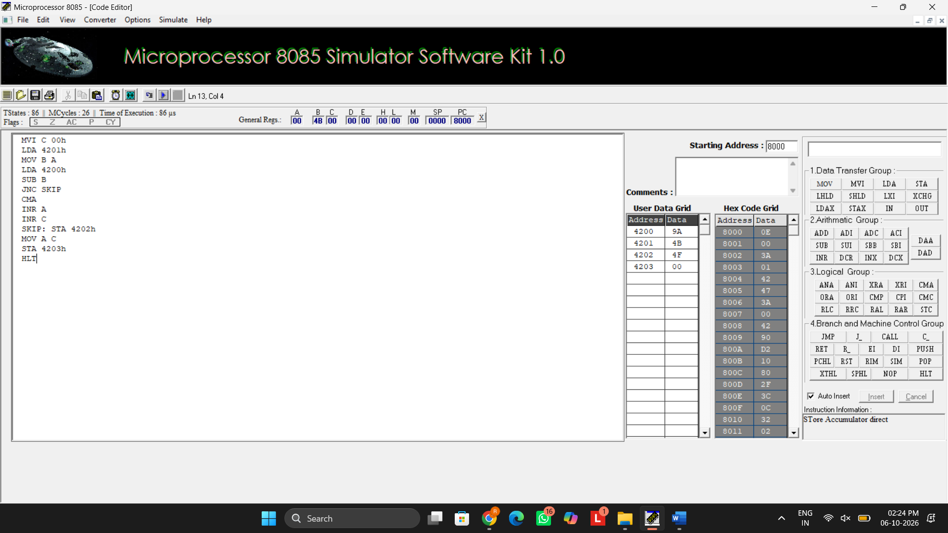

- verify assembly language programs for performing 8-bit multiplication and division using the 8085 microprocessor and check the accuracy of the results.

8 BIT MULTIPLICATION:
LDA 4201h
MOV E A
LDA 4202h
MOV C A
REPEAT: DAD D
DCR C
JNZ REPEAT
SHLD 4203h
HLT
OUTPUT
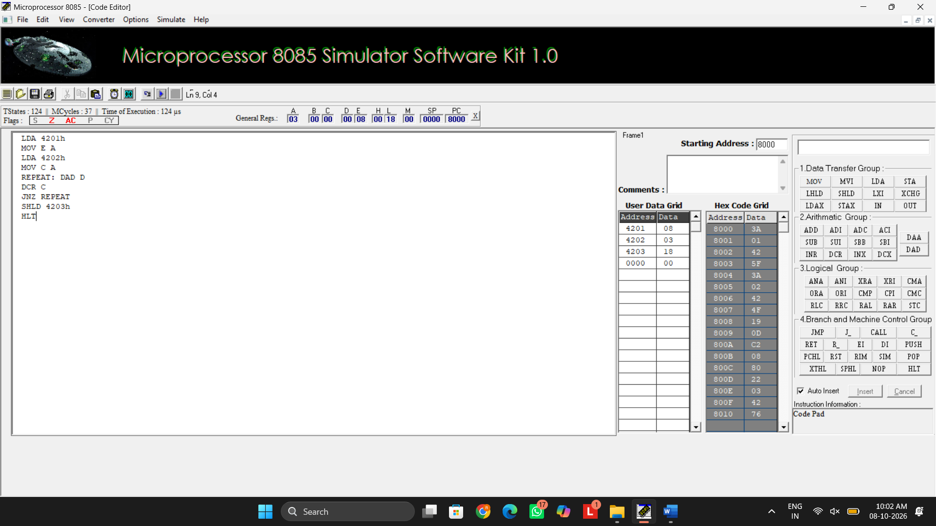
8 BIT DIVISION:
LDA 4201h
MOV B A
LDA 4200h
MVI C 00h
AGAIN: CMP B
JC STORE
SUB B
INR C
JMP AGAIN
STORE: STA 4203
MOV A C
STA 4202h
HLT

OUTPUT
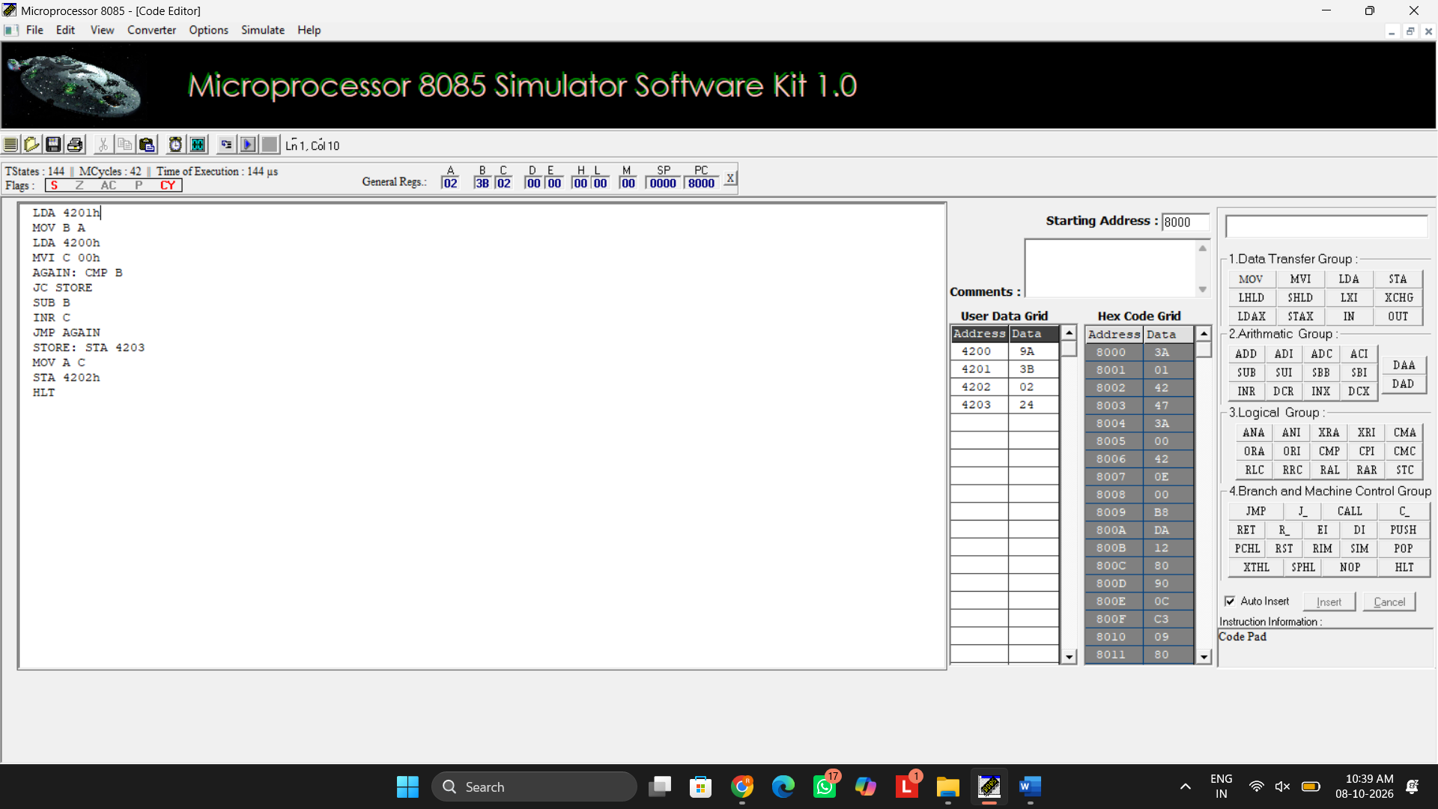

- verify assembly language programs for performing 16-bit addition and subtraction using the 8085 microprocessor and analyze the results obtained.

16 BIT ADDITION

LHLD 4200H
XCHG
LHLD 4202H
DAD D
SHLD 4204H
HLT

OUTPUT
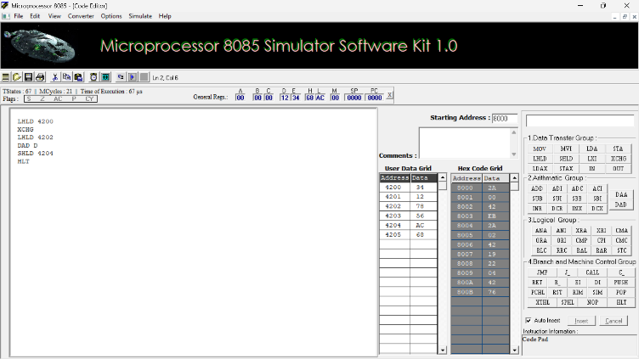
16 BIT SUBRACTION

LHLD 4200H
XCHG
LHLD 4202H
MOV A,L
SUB E
MOV L,A
MOV A,H
SBB D
MOV H,A
SHLD 4204H
HLT
OUTPUT
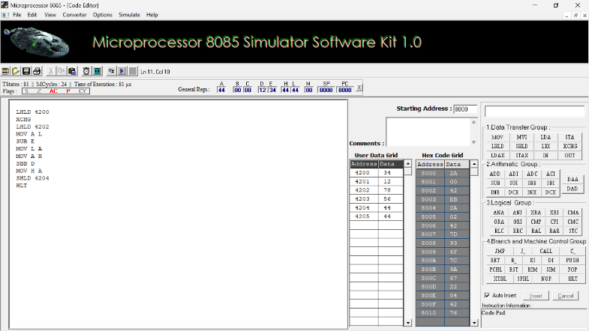

- verify assembly language programs for performing 16-bit multiplication and division using the 8085 microprocessor and validate the results obtained through memory locations.

16 BIT MULTIPLICATION
LHLD 2050H
XCHG
LHLD 2052H
MOV B,H
MOV C,L
LXI H,0000H
SHLD 2056H
MOV A,B
ORA C
JZ STORE
LOOP: DAD D
JNC NEXT
PUSH H
LHLD 2056H
INX H
SHLD 2056H
POP H
NEXT: DCX B
MOV A,B
ORA C
JNZ LOOP
STORE: SHLD 2054H
HLT

OUTPUT
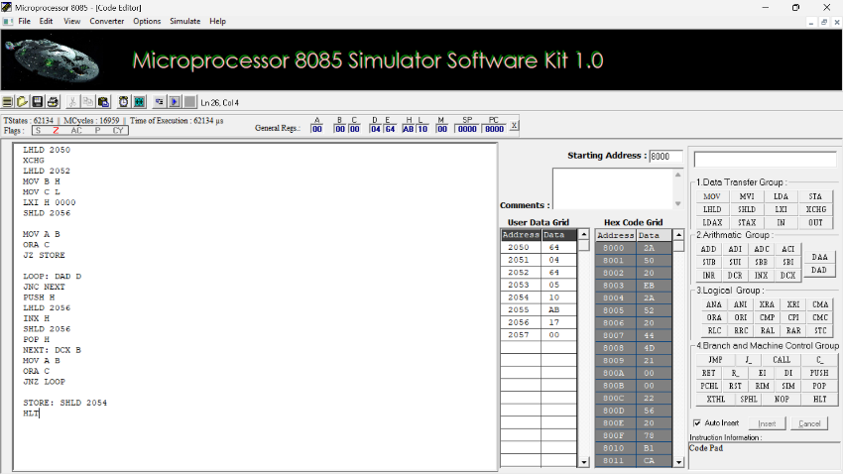

16 BIT DIVISION

LHLD 2050H
XCHG
LHLD 2052H
MOV B,H
MOV C,L
MOV A,B
ORA C
JZ STOP
LXI H,0000H
LOOP: MOV A,D
CMP B
JC DONE
JNZ SUBT
MOV A,E
CMP C
JC DONE
SUBT: MOV A,E
SUB C
MOV E,A
MOV A,D
SBB B
MOV D,A
INX H
JMP LOOP
DONE: SHLD 2054H
XCHG
SHLD 2056H
STOP: HLT

OUTPUT
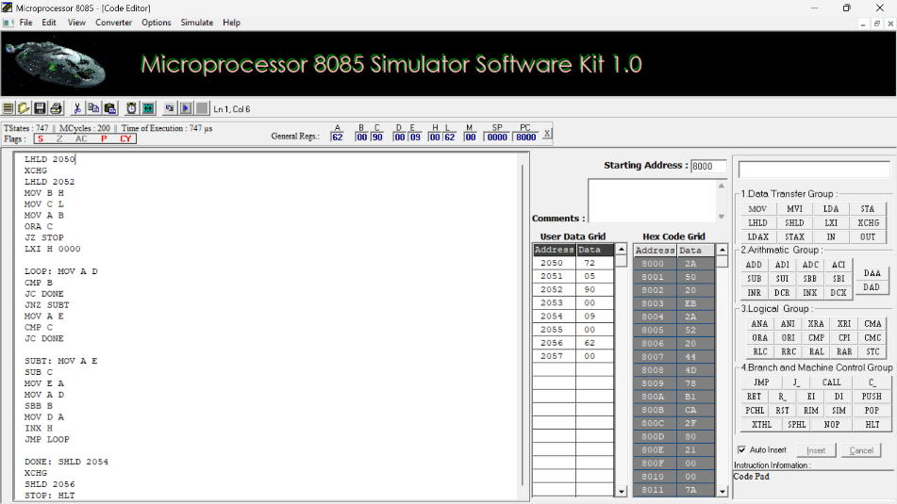

RESULT
Thus, the 8-bit and 16-bit arithmetic operations, including addition, subtraction, multiplication, and division, were successfully developed, executed, and verified using assembly language programs in the 8085 microprocessor simulator.

EXPERIMENT 02: LOGICAL, BIT-MANIPULATION AND SHIFT OPERATIONS USING 8-BIT AND 16-BIT DATA

Objective:
- To analyze, develop and verify logical AND, OR and XOR operations.
- To analyze, develop and verify one's and two's complement operations on 8-bit and 16-bit data.
- To analyze, develop and verify bit setting, clearing, toggling, rotate and shift operations.
- To verify the output results and carry flag using the 8085 simulator.

Components Required:
8085 Simulator

Procedure:
- Switch ON the 8085-microprocessor trainer kit.
- Enter the program opcodes at the specified starting memory address using the memory examine/substitute command.
- Store the required input data in the specified memory locations.
- Execute Program A from 4100H and Program B from 4200H using the GO/EXEC command.
- Examine the memory locations assigned for the output results and flag byte.
- Record the output values and verify them against the expected hexadecimal results.
- Repeat the procedure for both programs and record the observations.

  - Analysis of Logical Operations

PROGRAM [AND,OR,XOR in 8-bit ]
LXI H, 4500H MOV A, M INX H
MOV B, M ANA B PUSH PSW STA 4502H POP H MOV A, L STA 4509H LDA 4500H ORA B
STA 4503H LDA 4500H XRA B
STA 4504H HLT

OUTPUT
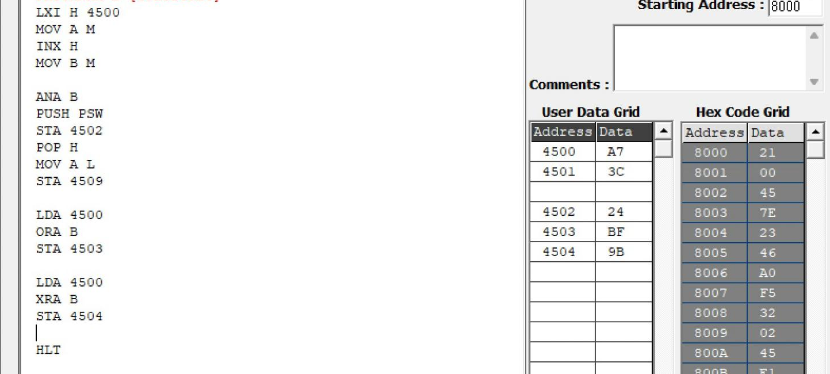

Memory | Data
4500H | A7H

4501H | 3CH
4502H | 24H
4503H | BFH
4504H | 9BH

PROGRAM [AND,OR,XOR in 16-bit ]
LDA 4500 MOV B A LDA 4502 ANA B STA 4504
LDA 4501 MOV B A LDA 4503 ANA B STA 4505
LDA 4500 MOV B A LDA 4502H ORA B STA 4506
LDA 4501
MOV B A LDA 4503 ORA B STA 4507
LDA 4500 MOV B A LDA 4502 XRA B STA 4508
LDA 4501 MOV B A LDA 4503 XRA B STA 4509 HLT

OUTPUT
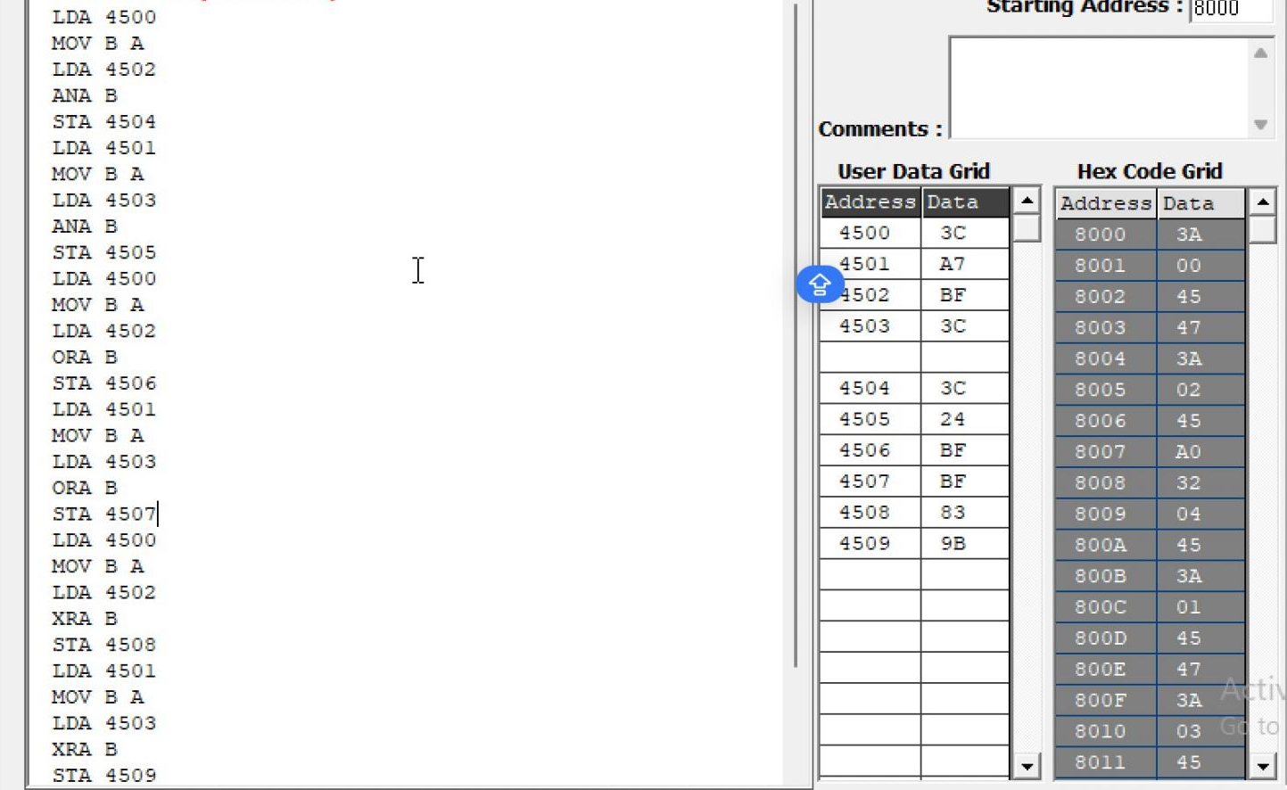

Memory | Data
4500 | 3CH
4501 | A7H
4502 | BFH
4503 | 3CH
4504 | 3CH
4505 | 24H
4506 | FFH
4507 | BFH
4508 | 83H
4509 | 9BH

  - Analysis of One's and Two's Complement

PROGRAM [16-bit]
LDA 4500H ANI 0FH STA 4505H LDA 4500H ANI F0H STA 4506H LDA 4500H CMA
STA 4507H INR A
STA 4508H
LHLD 450AH MOV A, L CMA
MOV L, A
MOV A, H CMA MOV H, A
SHLD 450CH INX H
SHLD 450EH HLT

OUTPUT
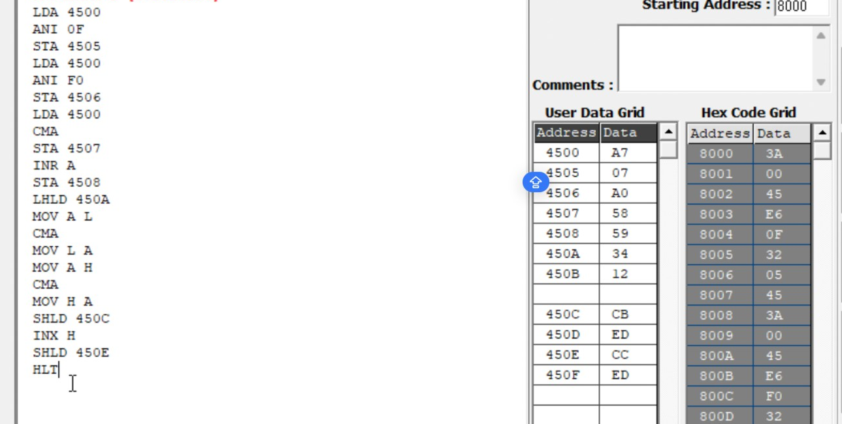
Memory | Data
4500 | A7
4505 | 07
4506 | A0
4507 | 58
4508 | 59
450A | 34
450B | 12
450C | CB
450D | ED
450E | CC
450F | ED

  - Analysis of Bit Setting, Clearing, Rotate

PROGRAM [Bit Manipulation]
LDA 4510H ORI 81H STA 4511H LDA 4510H ANI F5H STA 4512H LDA 4510H XRI 0FH STA 4513H MVI C, 00H LDA 4510H ANI 40H
JZ NEXT INR C
NEXT: MOV A, C
STA 4514H LDA 4510H RLC
STA 4515H LDA 4510H RRC
STA 4516H LDA 4510H ORA A
RAL
STA 4517H LDA 4510H ORA A
RAR
STA 4518H LDA 4510H MOV B, A RAL
MOV A, B RAR
STA 4519H LDA 4510H MVI B, 08H MVI C, 00H CNT: RLC

JNC SKIP INR C
SKIP: DCR B JNZ CNT MOV A, C STA 451AH HLT

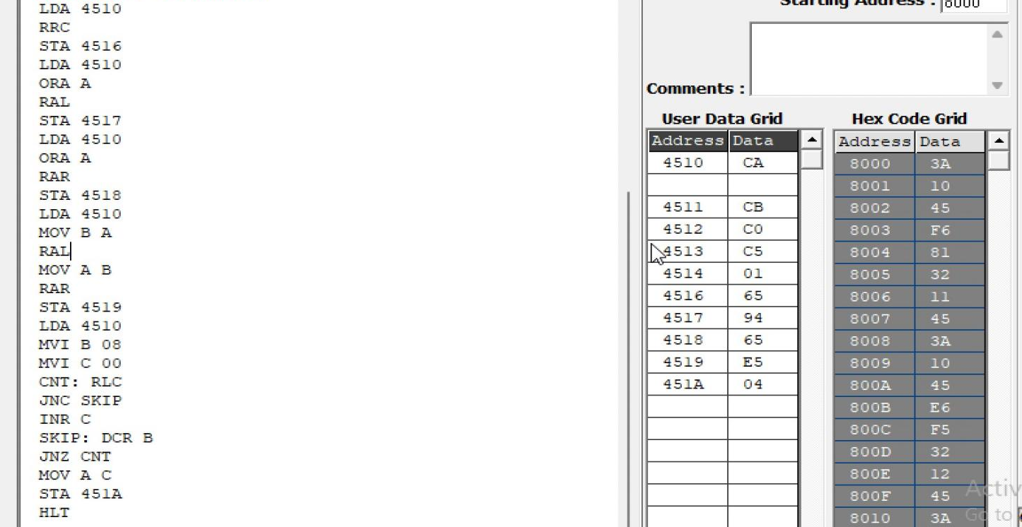
OUTPUT

Memory | Data
4510H | CAH
4511H | CBH
4512H | C0H
4513H | C5H
4514H | 01H
4515H | 95H
4516H | 65H
4517H | 94H
4518H | 65H
4519H | E5H
451AH | 04H

  - Analysis of Shift Operations

PROGRAM [16-bit Shift Left]
LHLD 4520H DAD H
SHLD 4522H HLT

OUTPUT
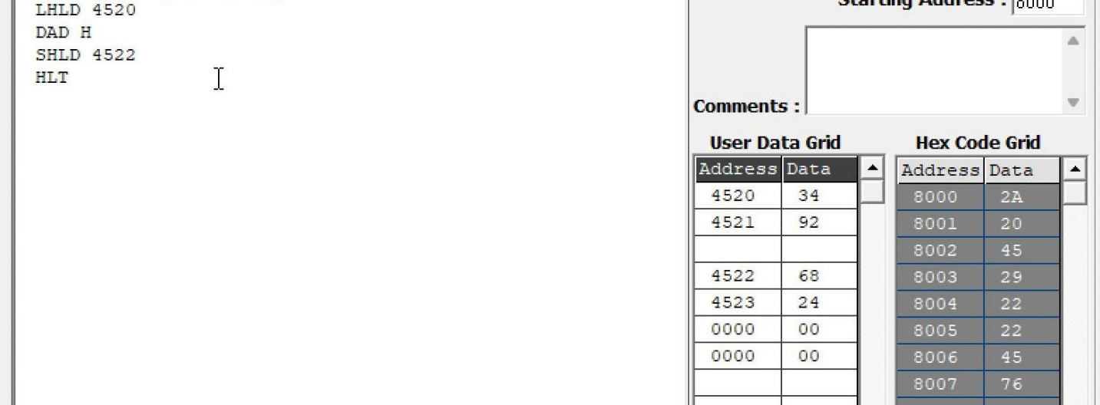

Memory | Data
4520H | 34H
4521H | 92H
4522H | 68H
4523H | 24H

Result:
Thus, the logical, bit-manipulation, complement, rotate and shift operations were performed using the 8085 simulator. The output values were examined in memory and verified against the expected hexadecimal results.

